**Create 2 VPC and subnets in each along with VM’s in 2 different regions and try to ping the VM’s.**

**Login to aws console and go to vpc and more and create vpc and subnet with mumbai region**

**Name-sri-mumbai, Ip-10.90.0.0/16**

-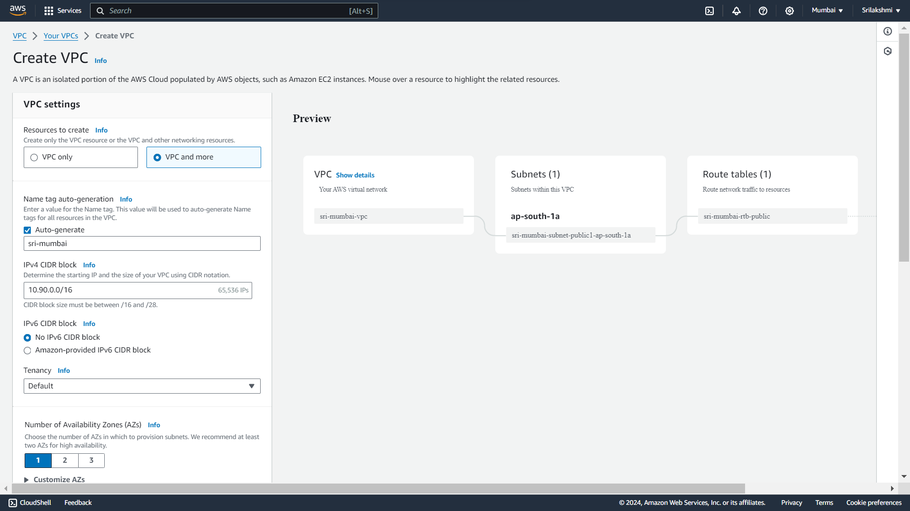

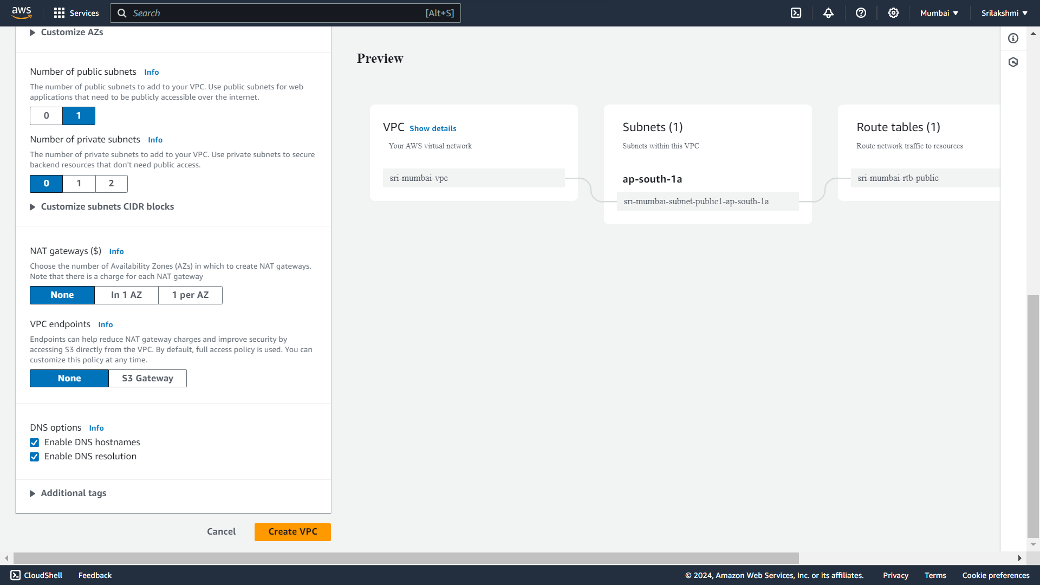

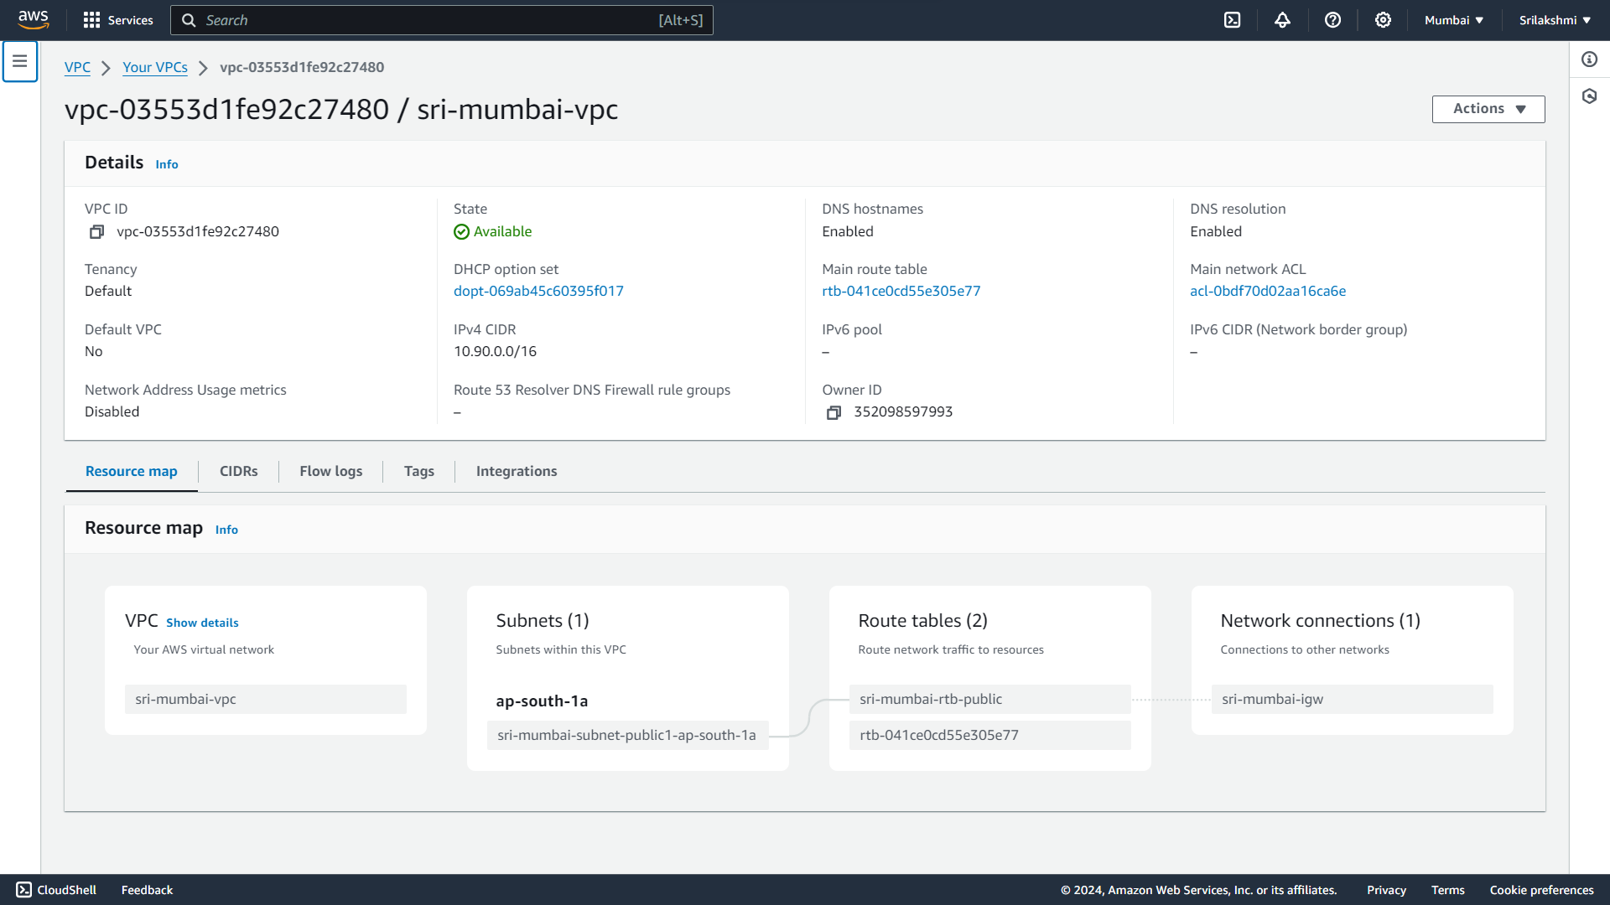

**Create another vpc and subnet with hyd region**

**Name-srihyd, IP-172.50.0.0/16**

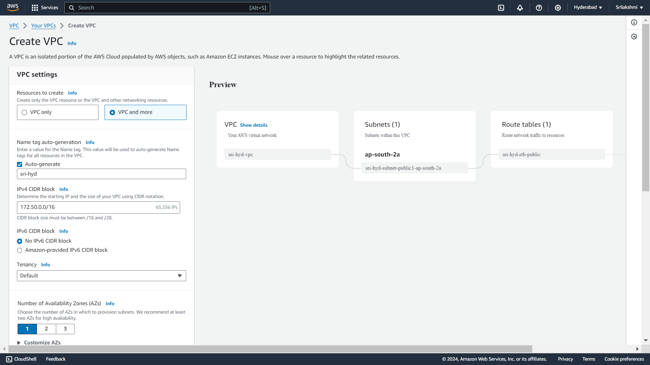

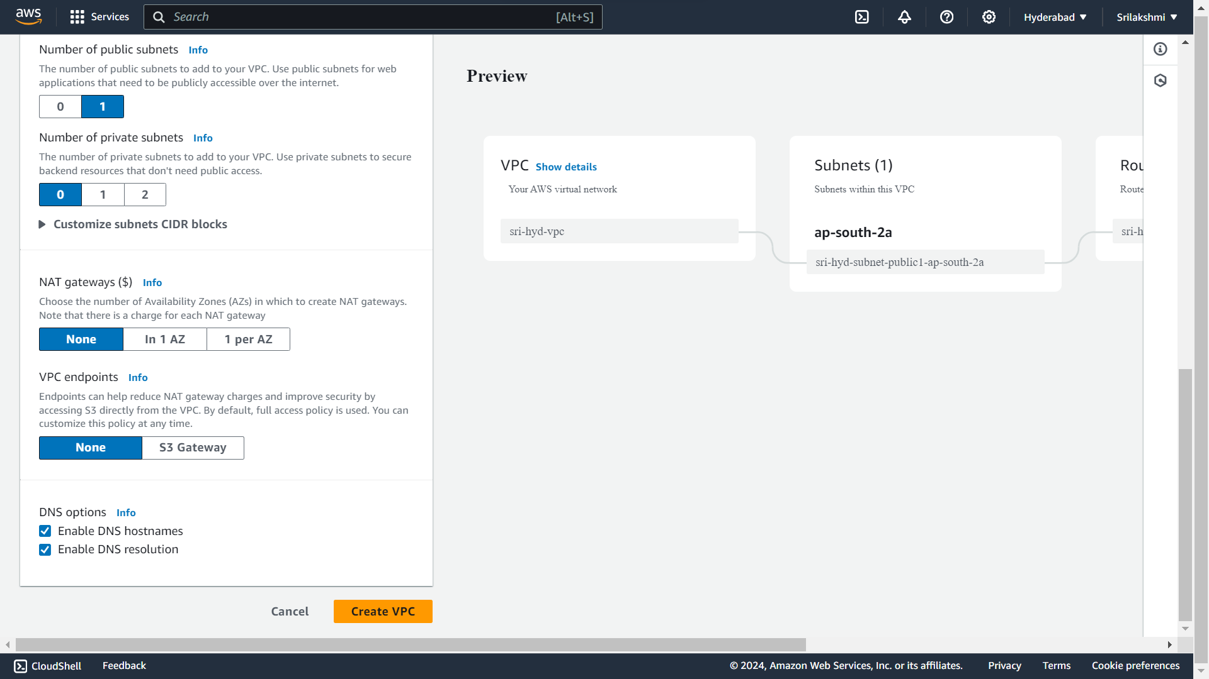

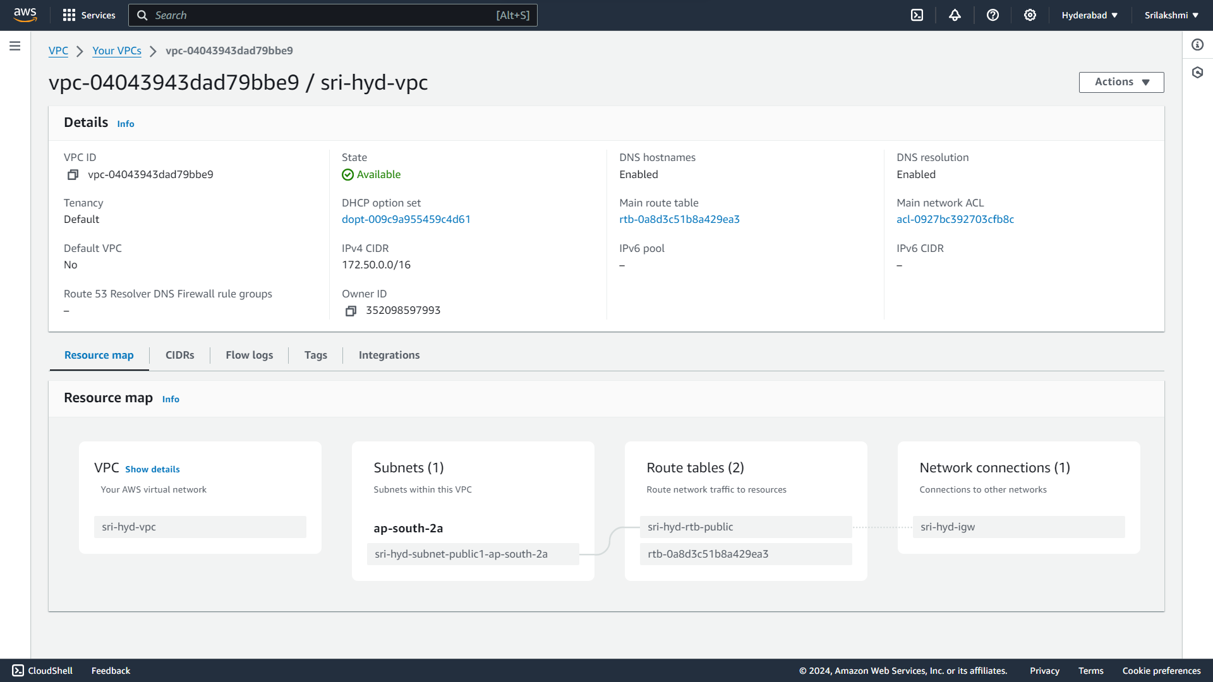

**Go to ec2 and create instance with mumbai region**

**Name-sriserver-mumbai, OS Image-Ubuntu**

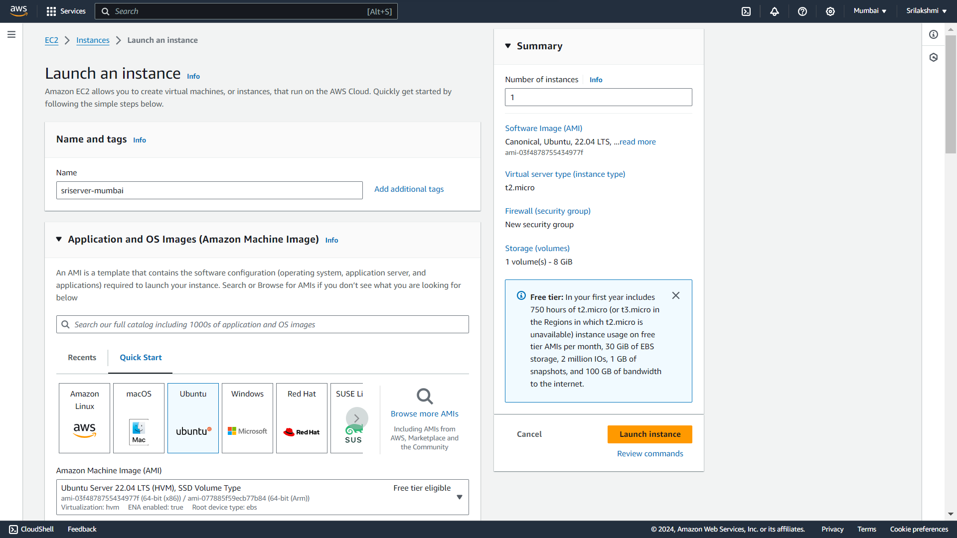

**Give instance type-t2.micro, key pair-sritaskkey**

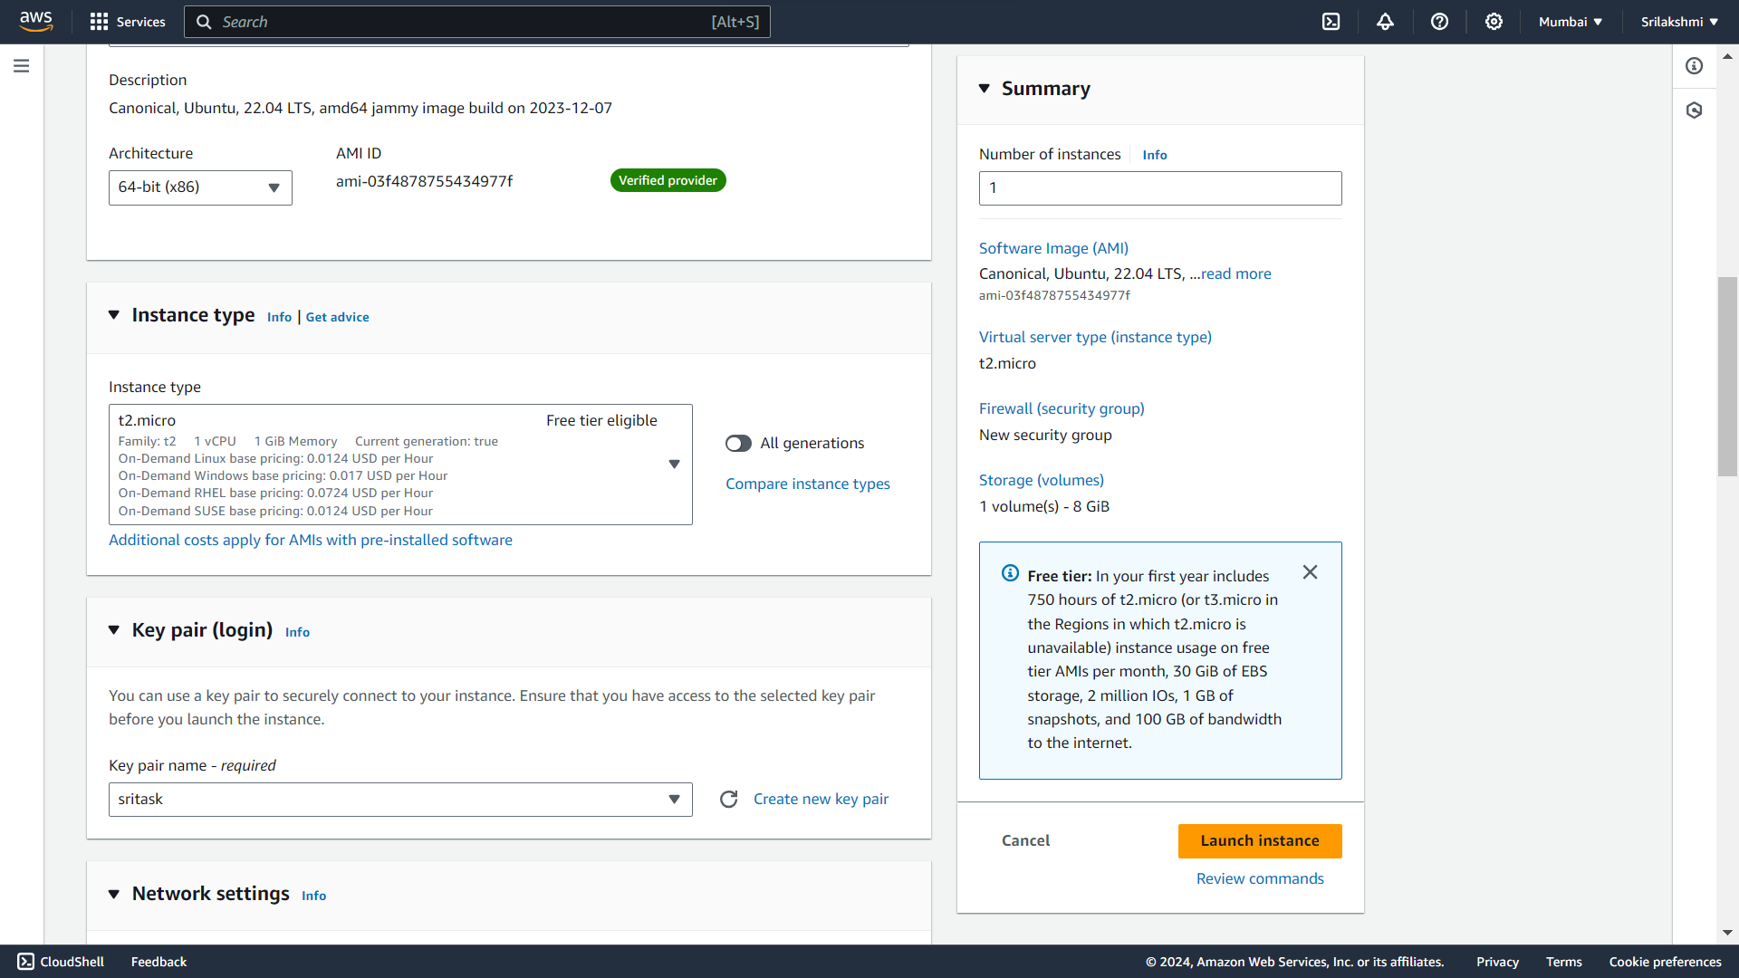

**Create Network settings with mumbai region and subnet  
Security group-sri-mumbai-sg and add rules**

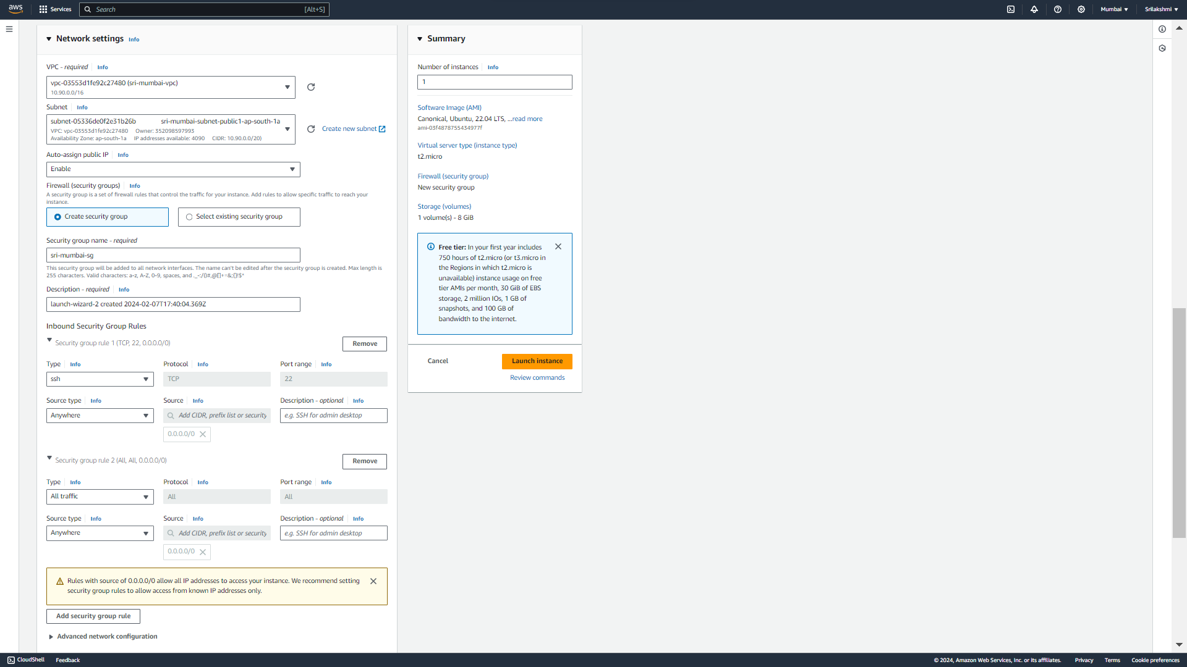

**Configure default storage-general purpose 8gb and click on launch instance**

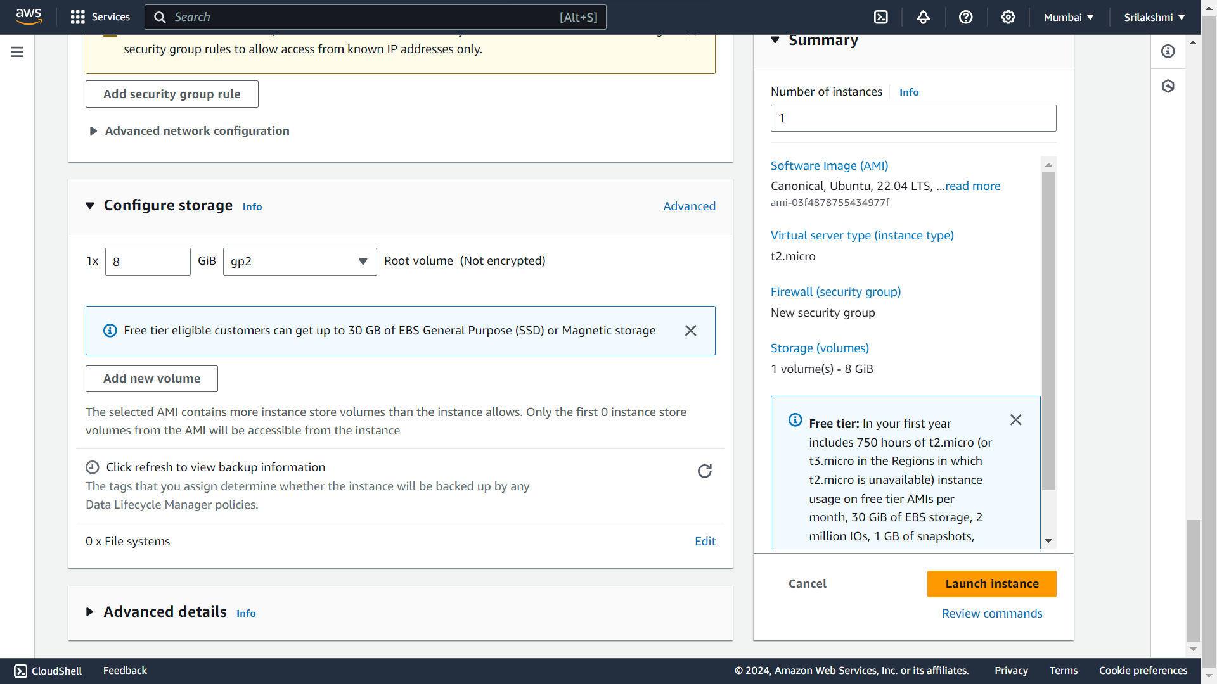

**This is the mumbai instance view**

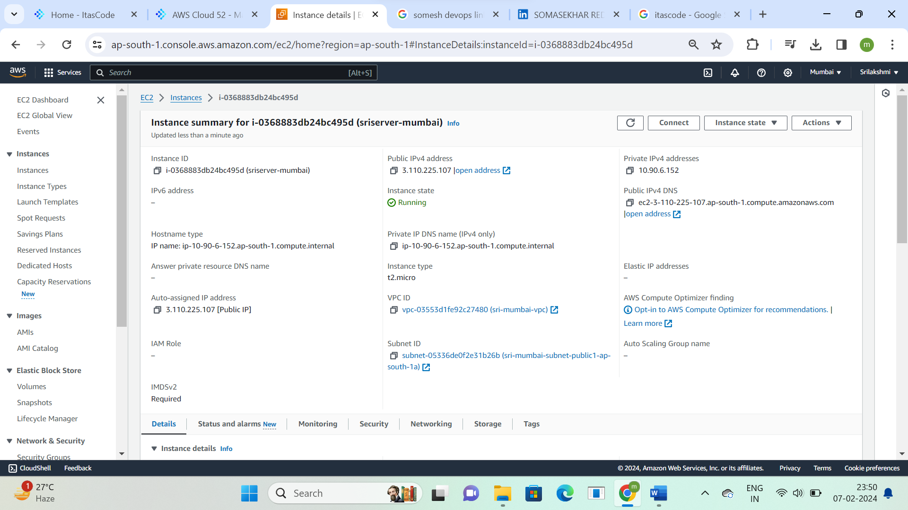

**Create another instance with hyd region  
Name-sriserver-hyd, OS Image-Ubuntu**

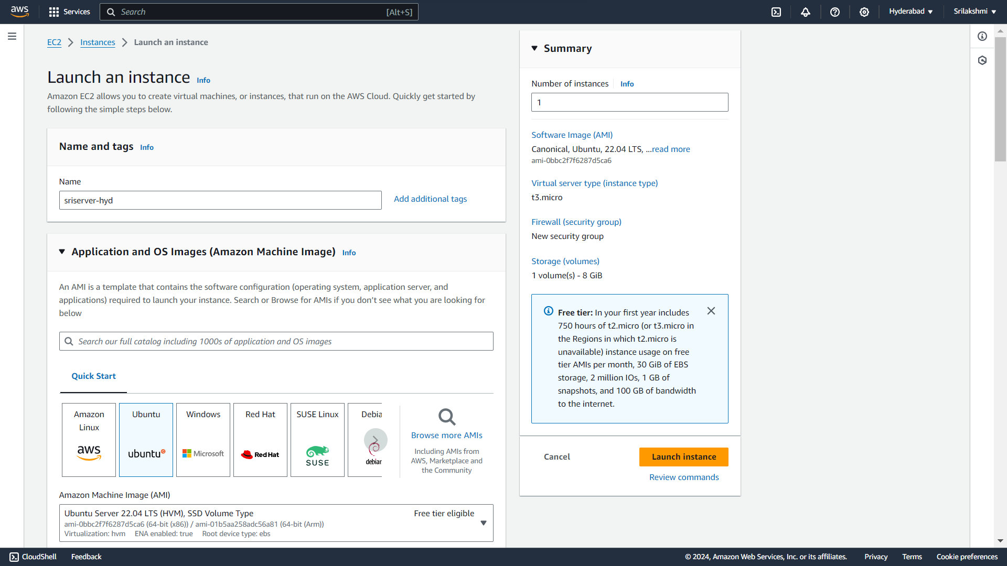

**Give instance type-t2.micro, key pair-sri-taskkey**

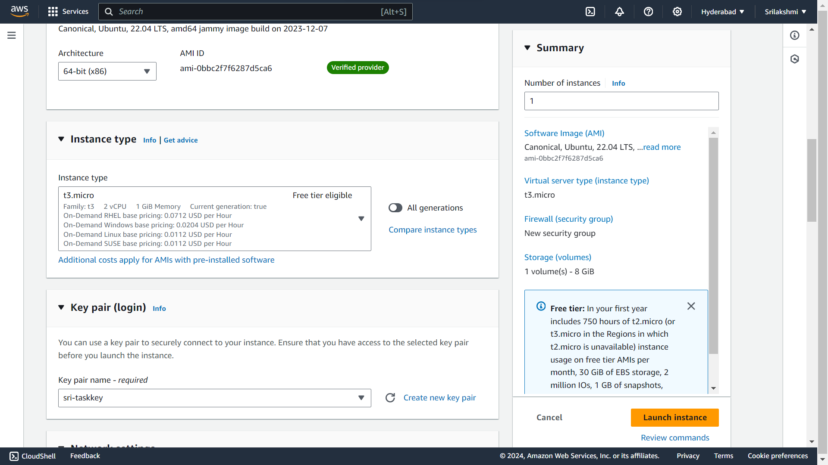

**Create Network settings with hyd region and subnet  
Security group-sri-hyd-sg and add rules**

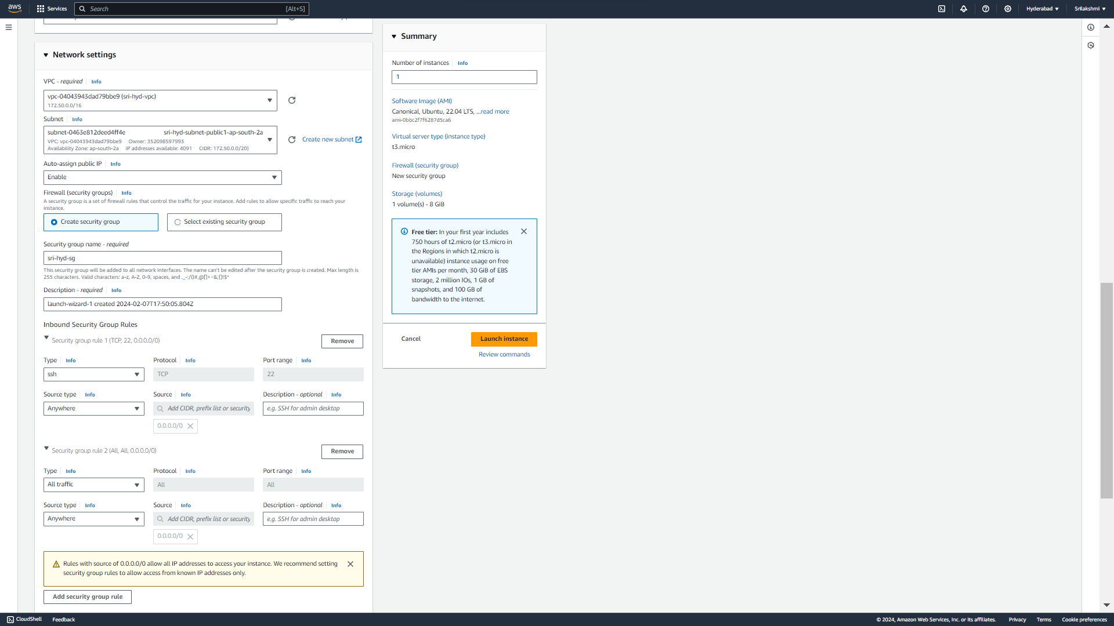

**Configure default storage-general purpose 8gb and click on launch instance**



**This is the hyd instance view**

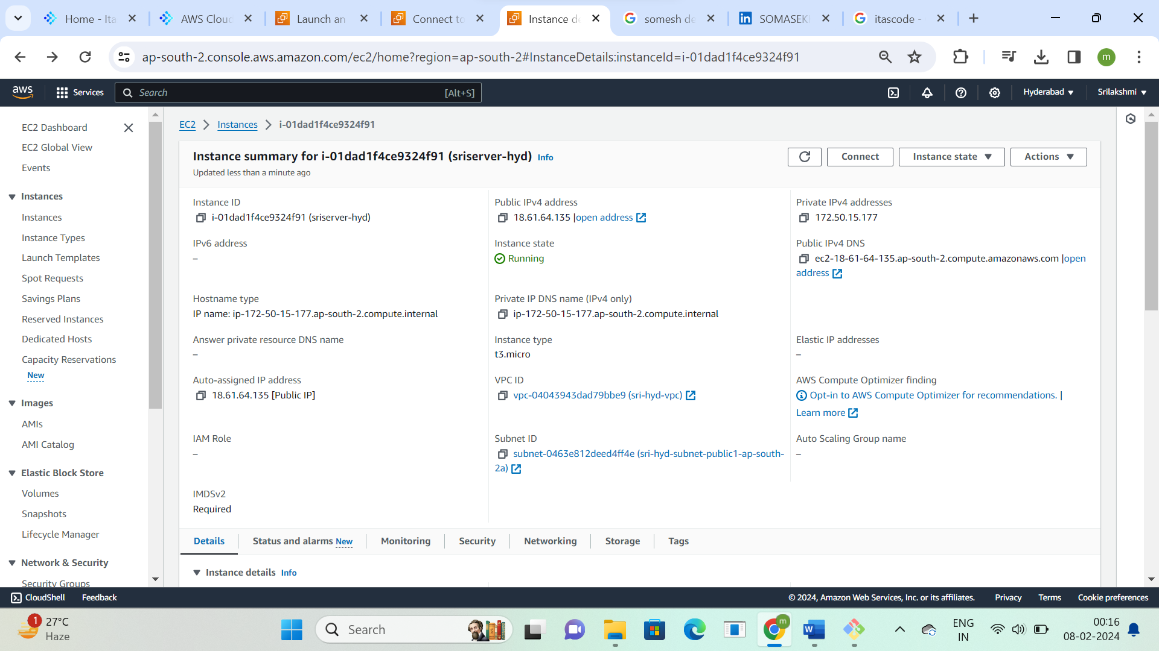

**Now connect the mumbai region server  
Click on connect**



**Go to SSH client and copy ssh command**

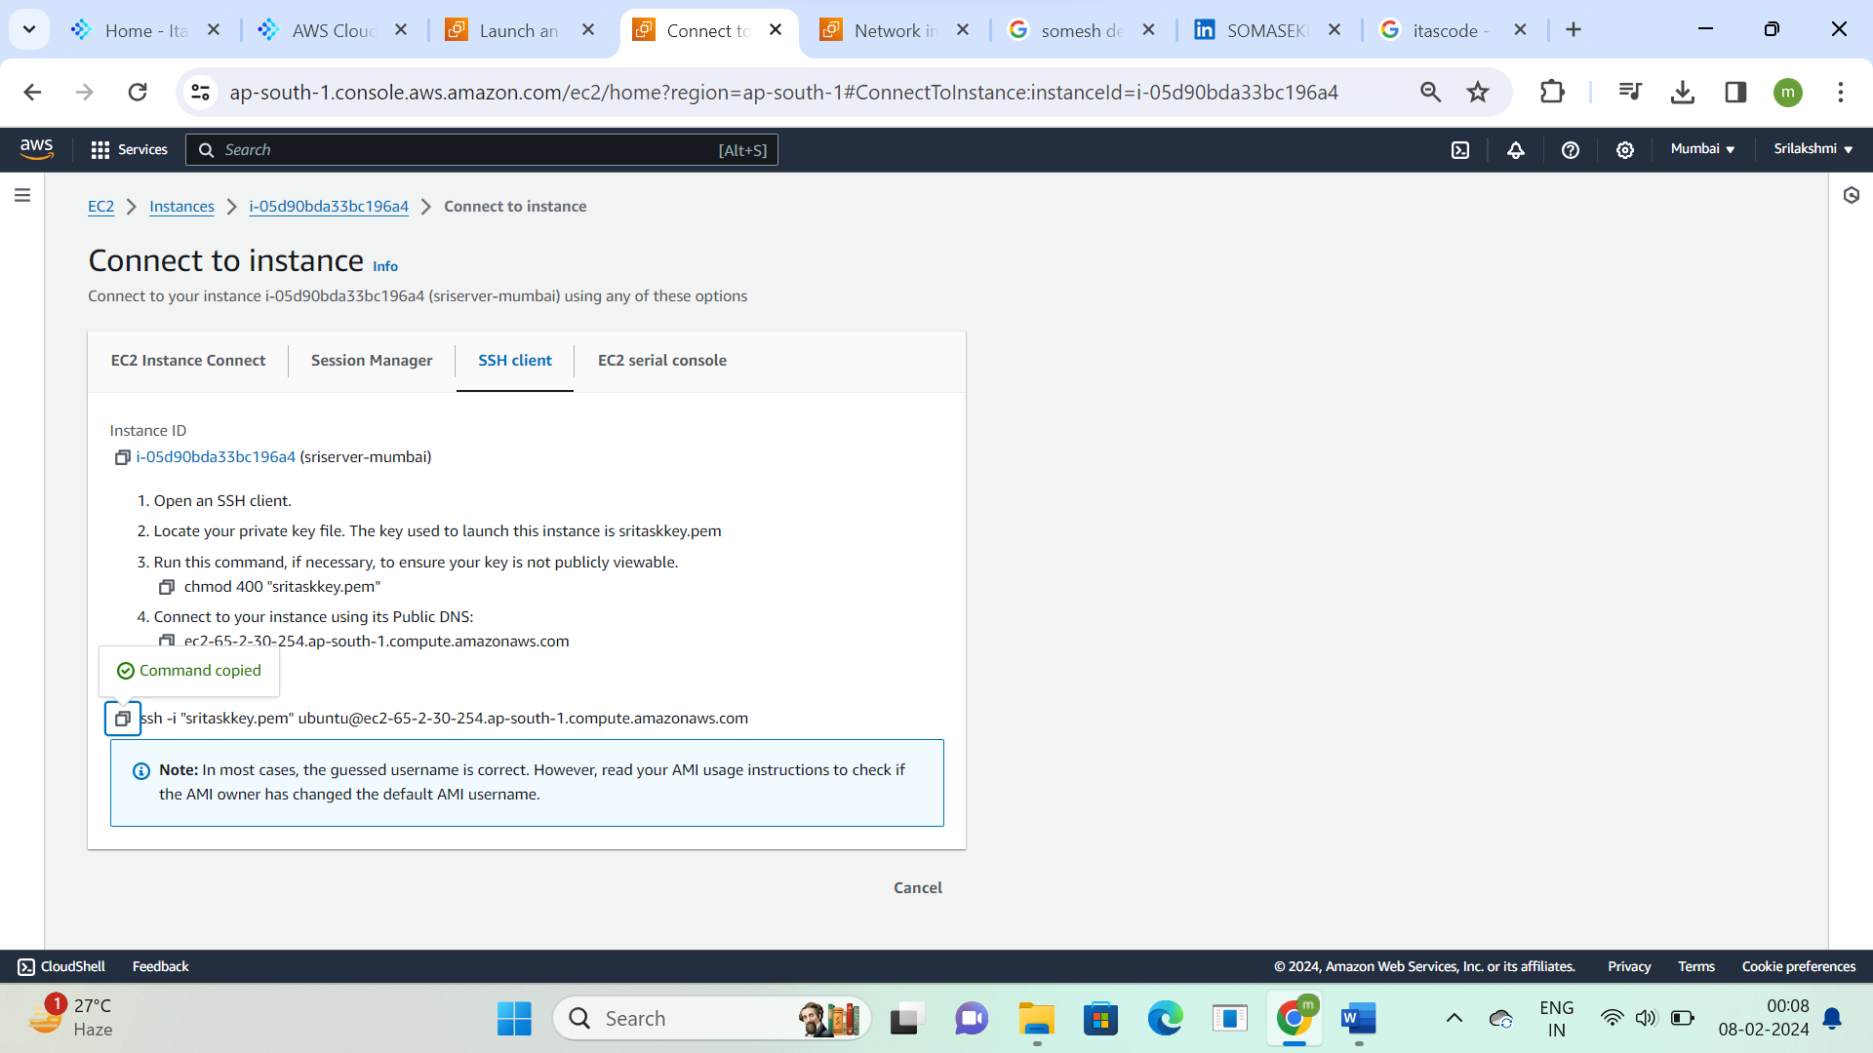

**Git bash the downloaded key for mumbai region server**

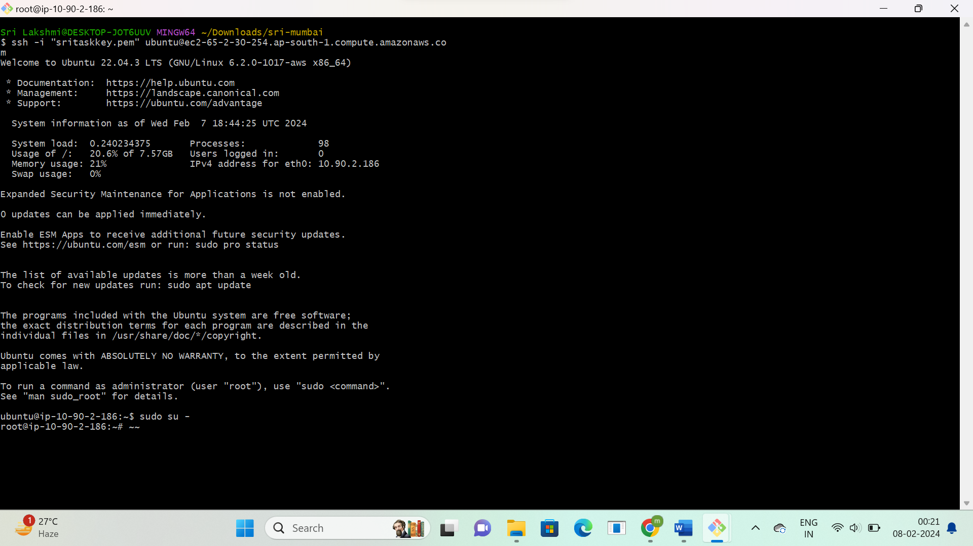

**Now connect the hyd region server  
Click on connect**



**Go to SSH client and copy ssh command**

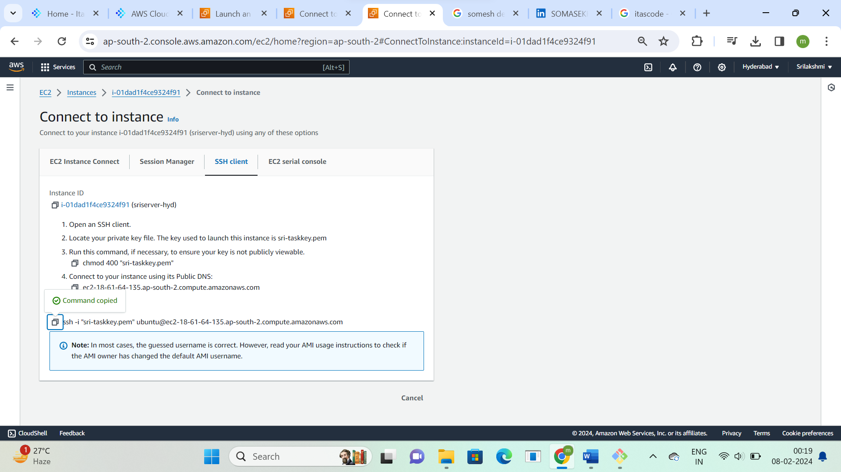

**Git bash the downloaded key for hyd region server**

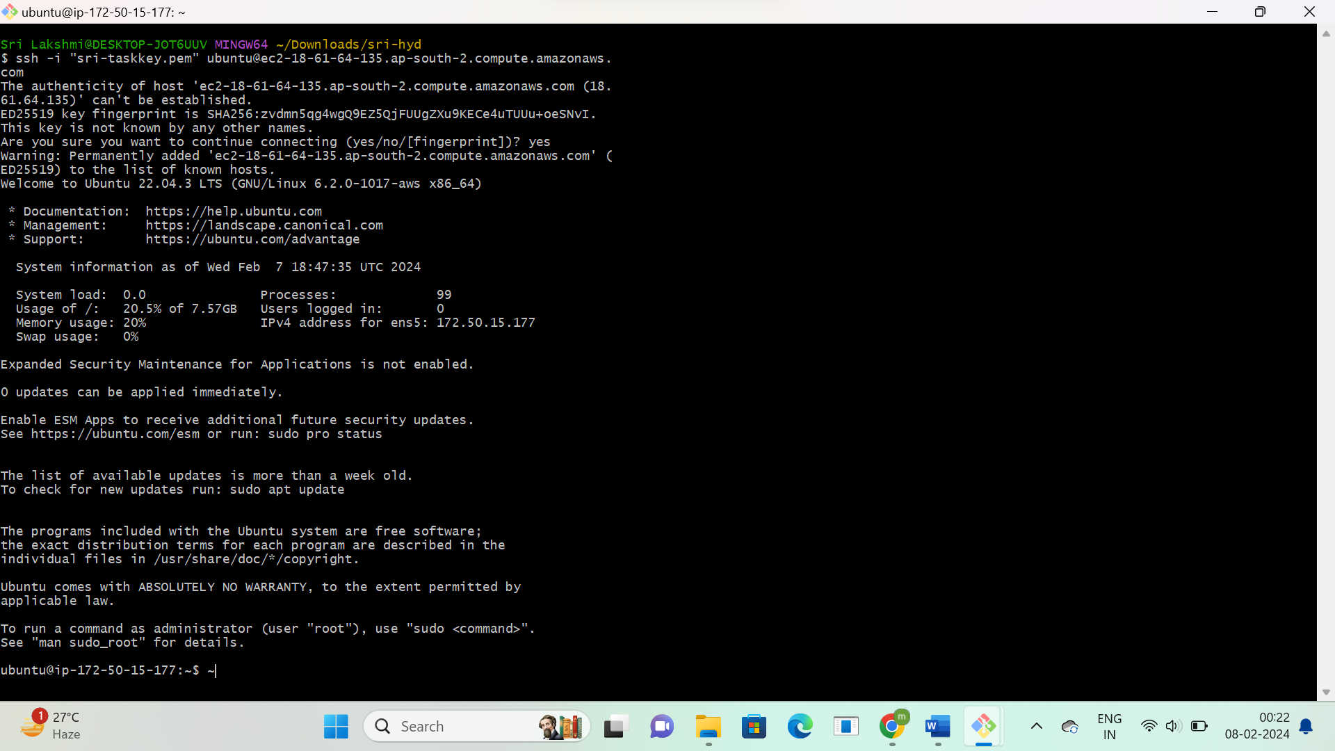

**Click on create peering connection**

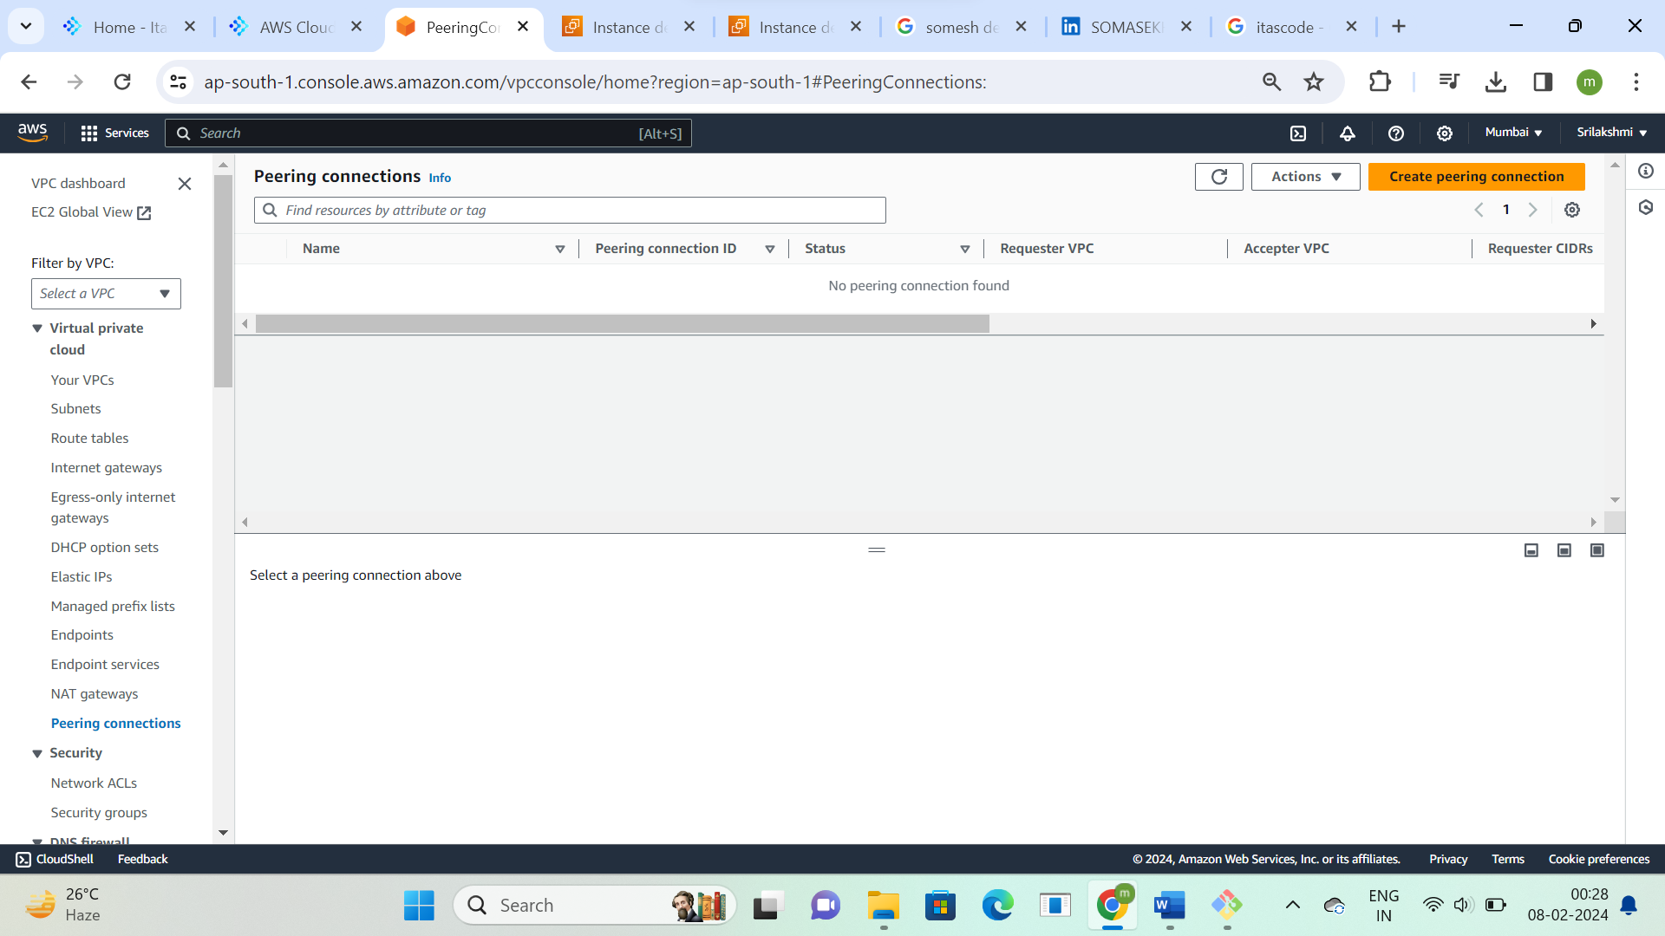

**Create peering connection  
Name-sri-mumbai-hyd-peering as receiver, select hyd region for peering as acceptor and give vpc ids**

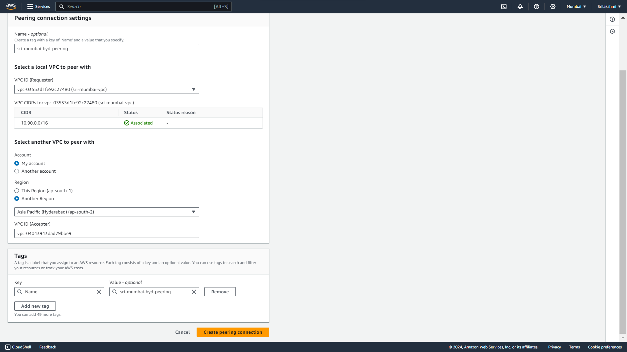

**After creating Peering request will be sent from another region hyd**

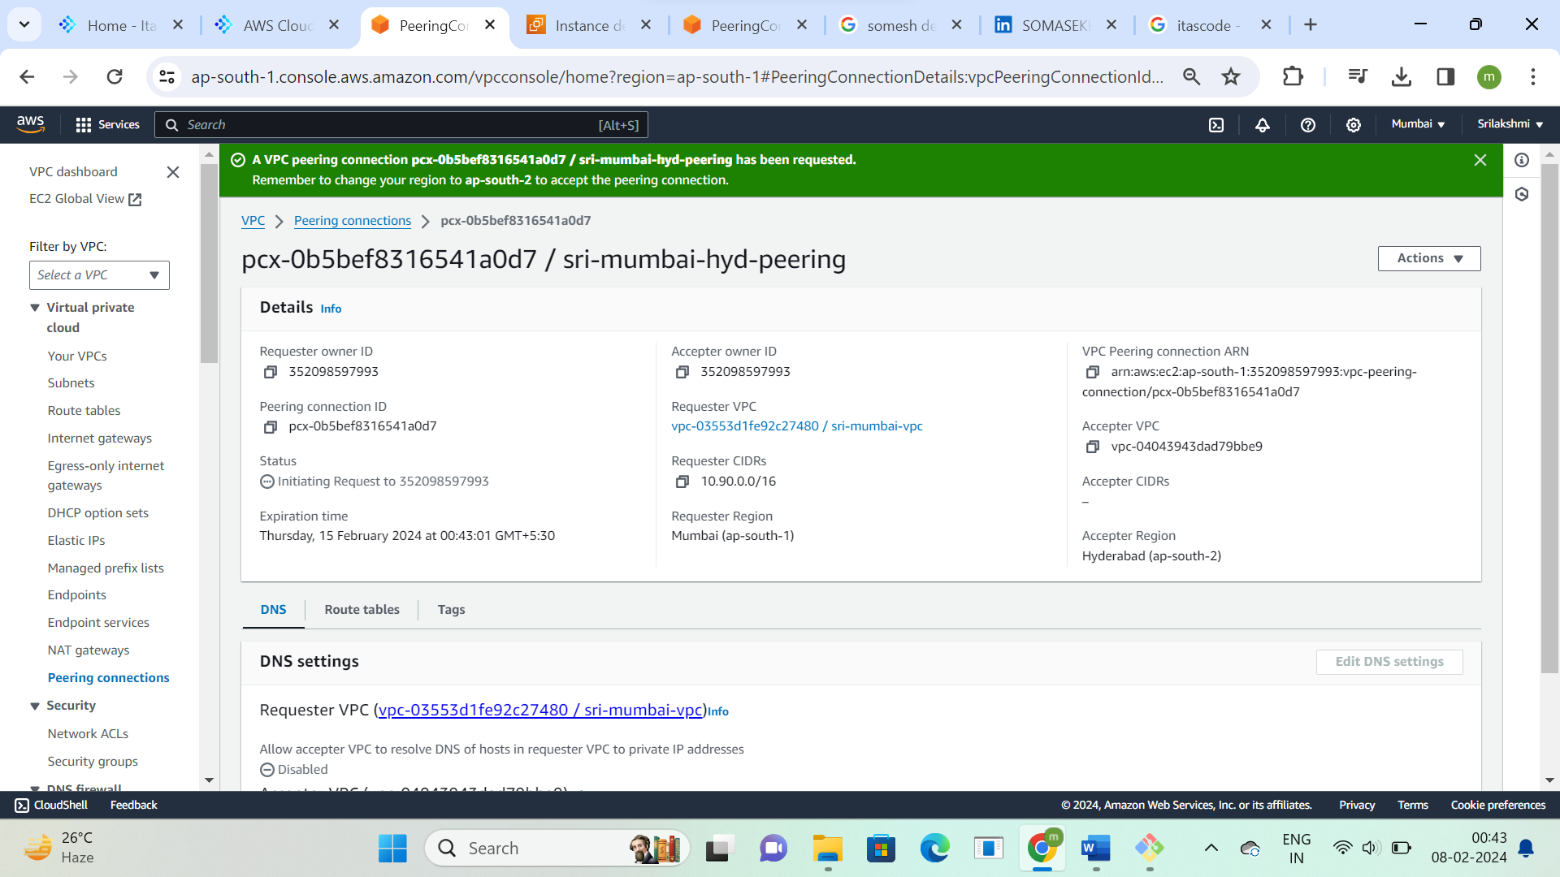

**Go to another region-hyd and click on actions and accept request**

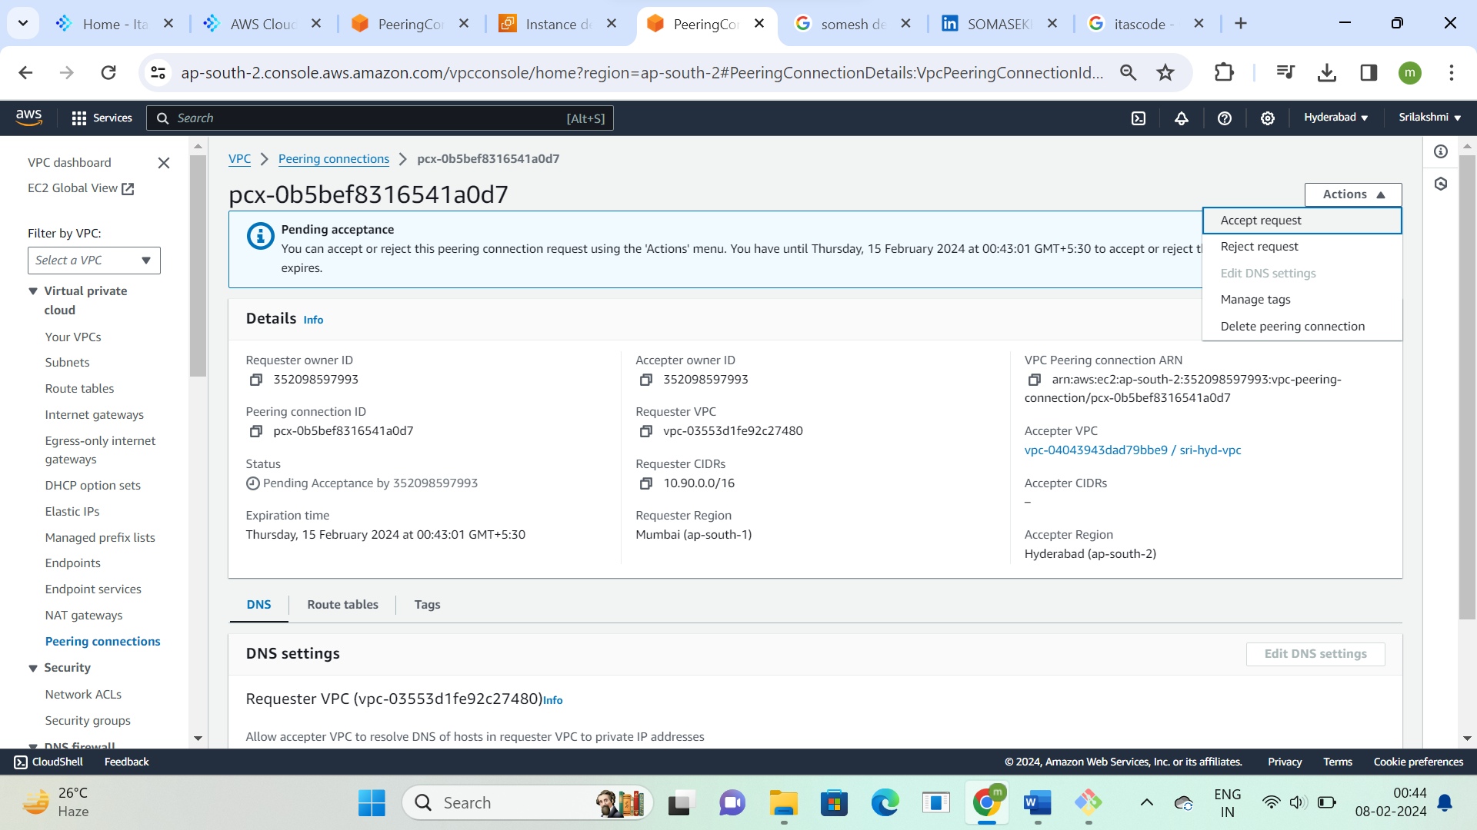

**Accept the peering request connection**

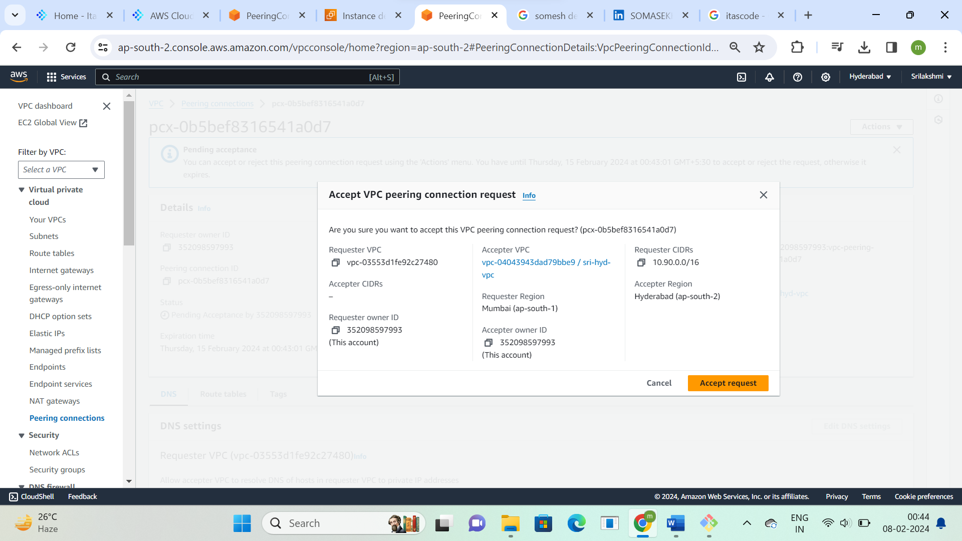

**Peering request has been established and click on modify routes tables**

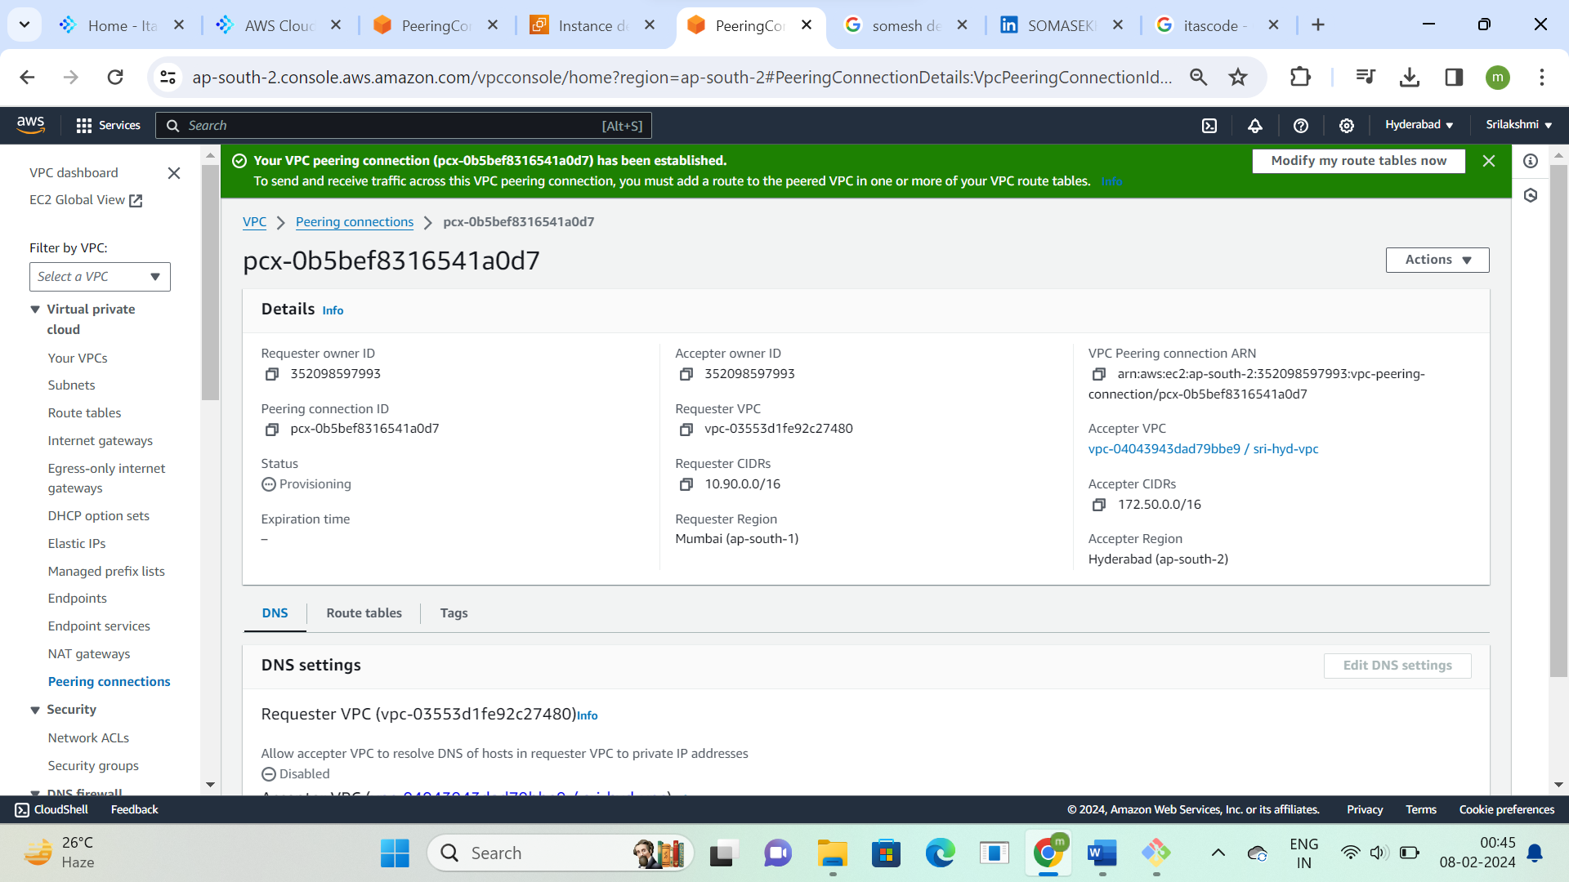

**Edit route tables and give mumbai region vpc Ip address and peering connection Id in hyd region  
route table and click on save changes**

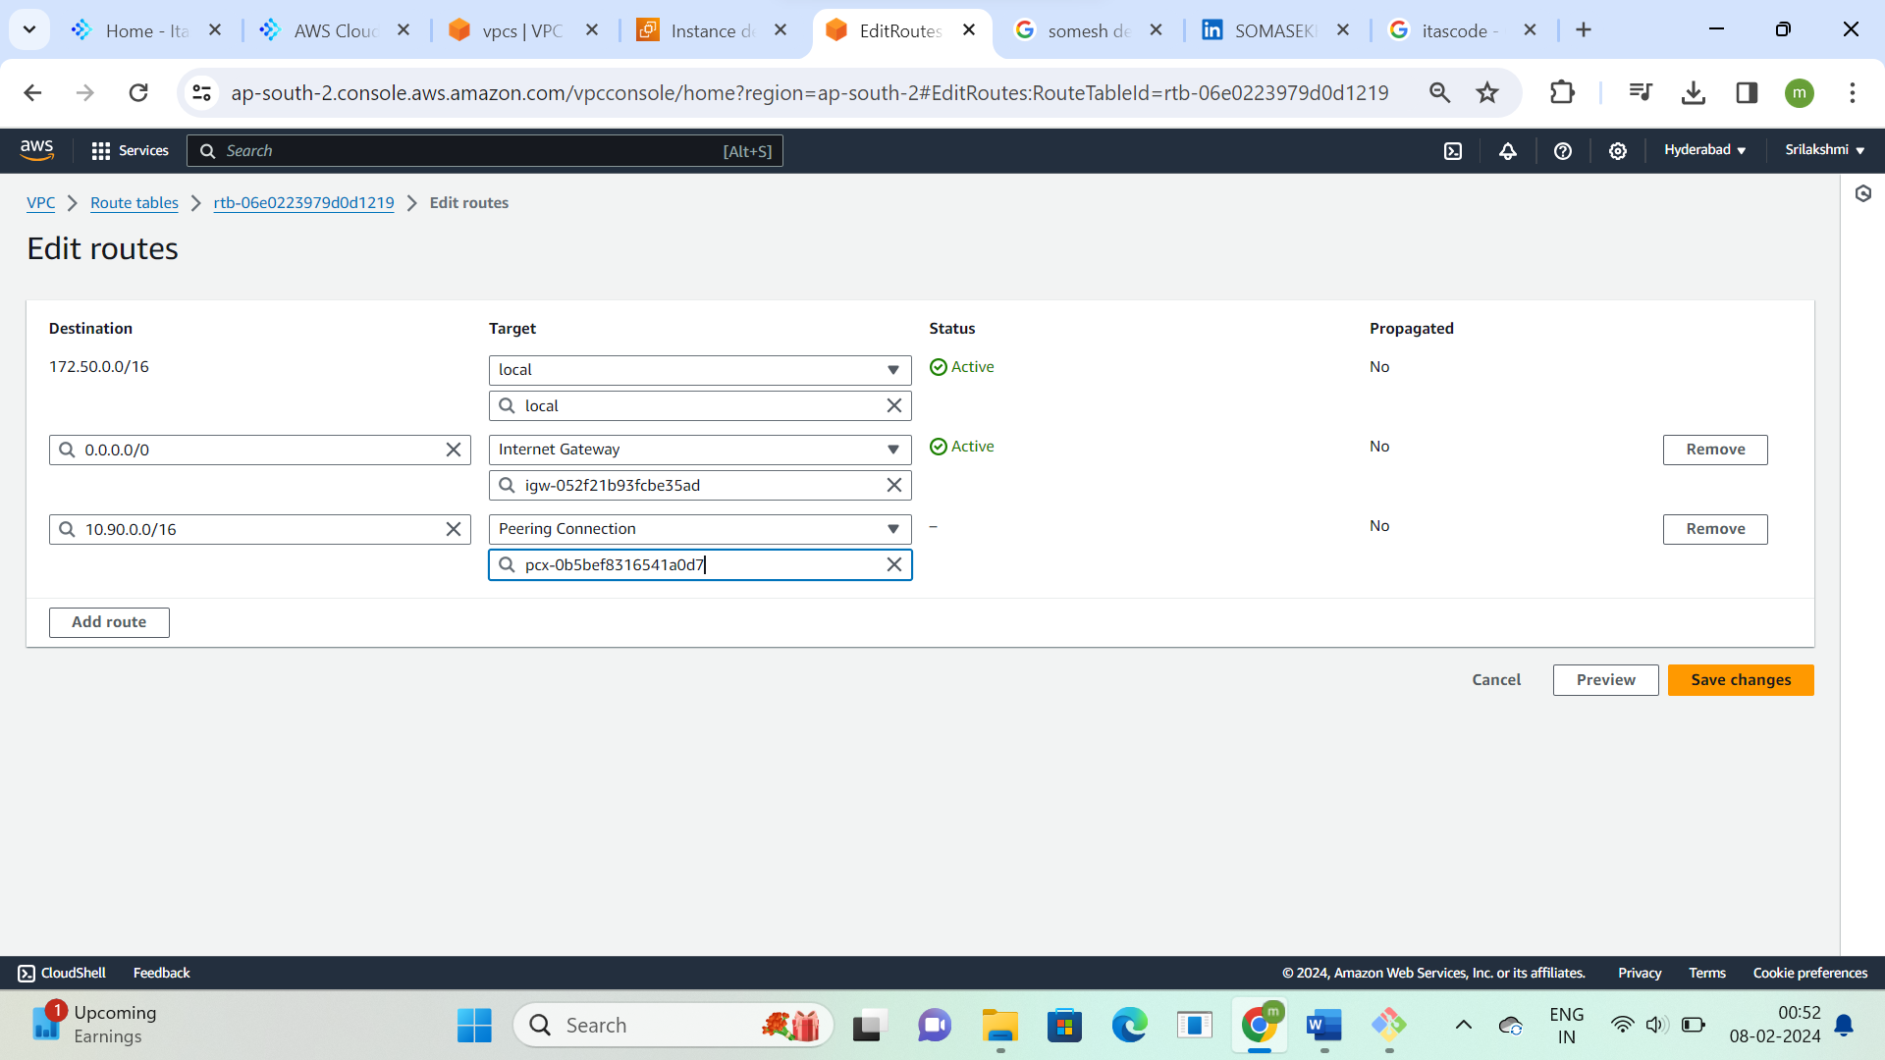

**This is the route table, Automatically it will add subnet id**

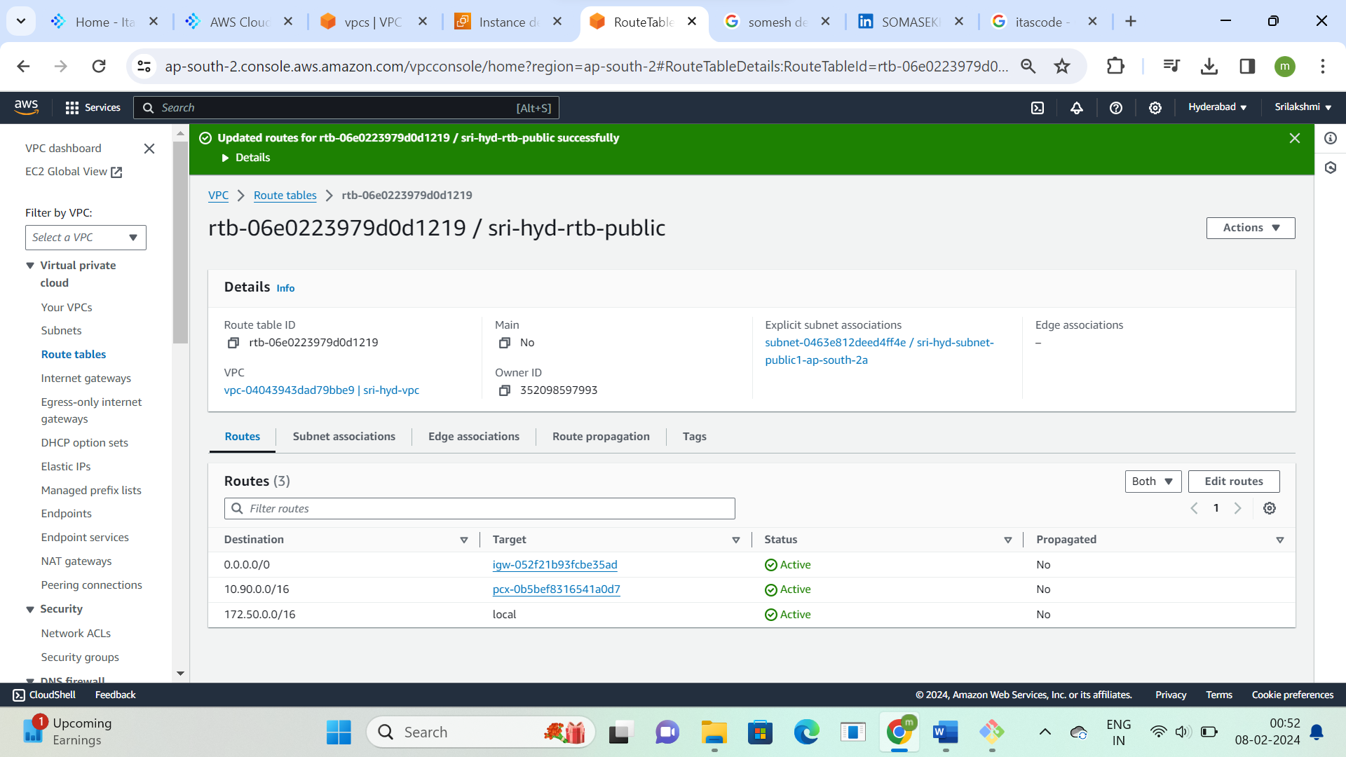

**Edit route tables and give hyd region vpc Ip address and peering connection Id in mumbai region   
route table and click on save changes**

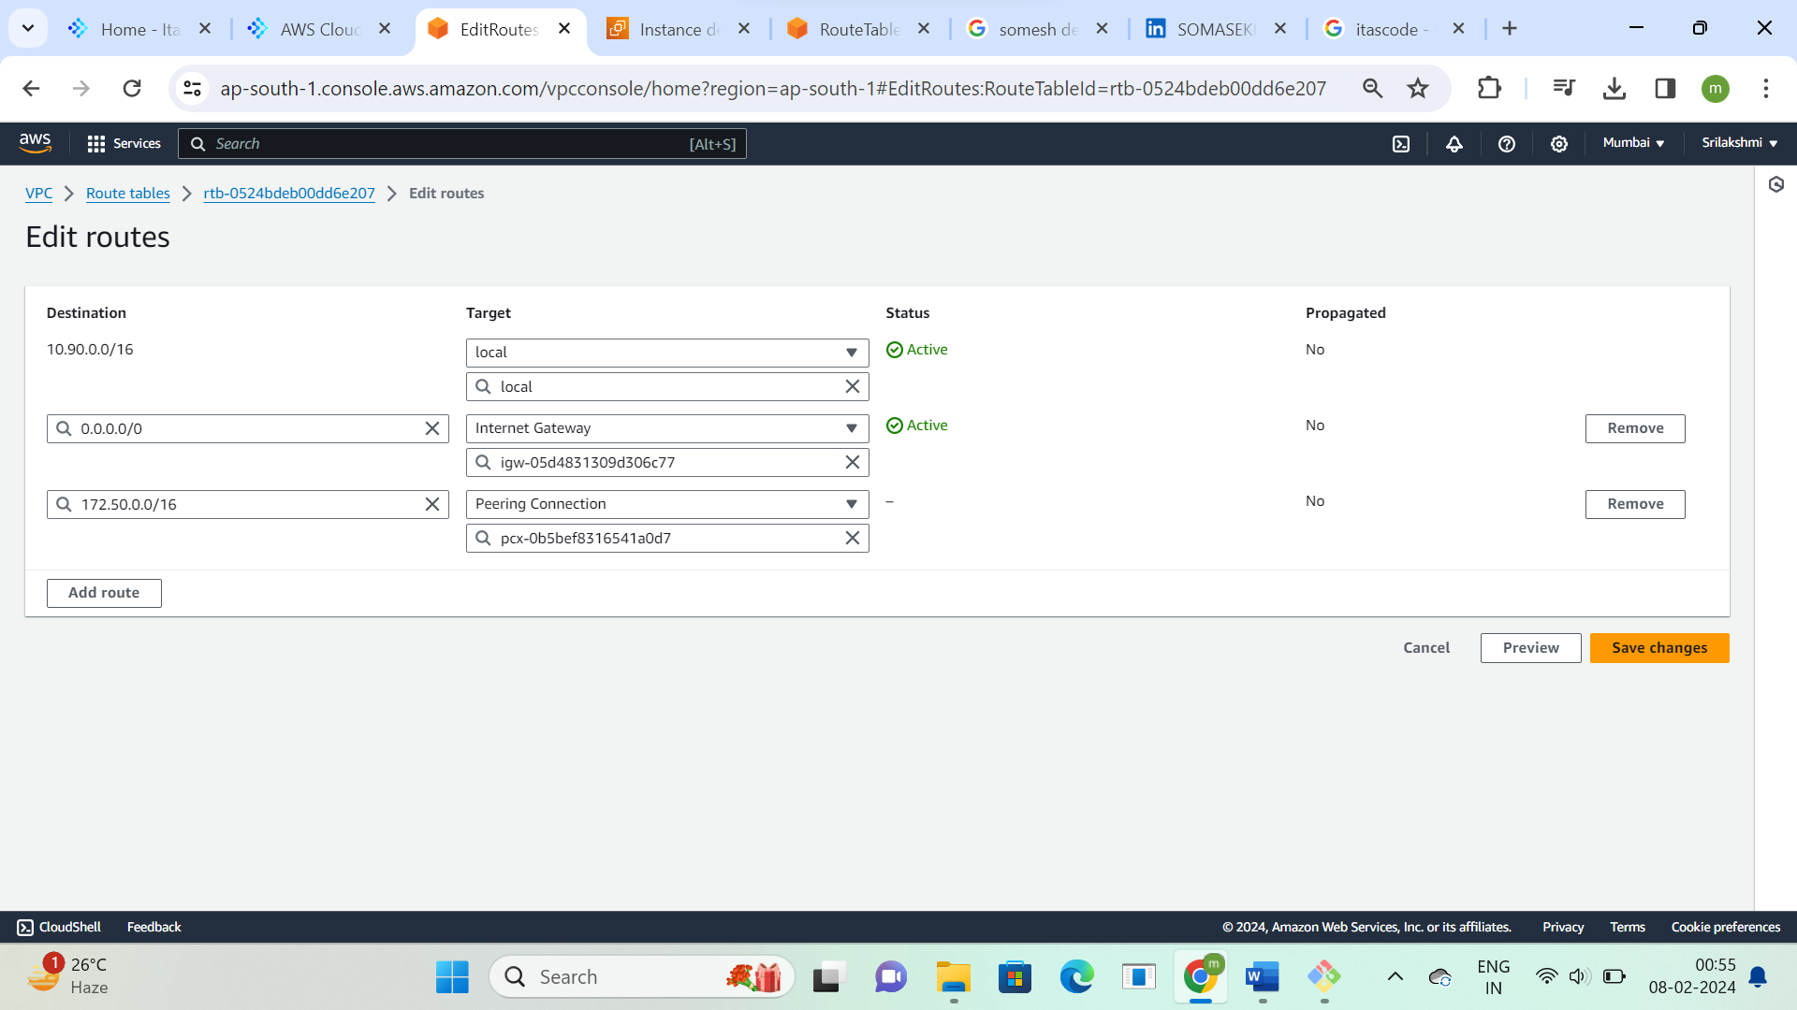

**This is the route table, Automatically it will add subnet id check it**

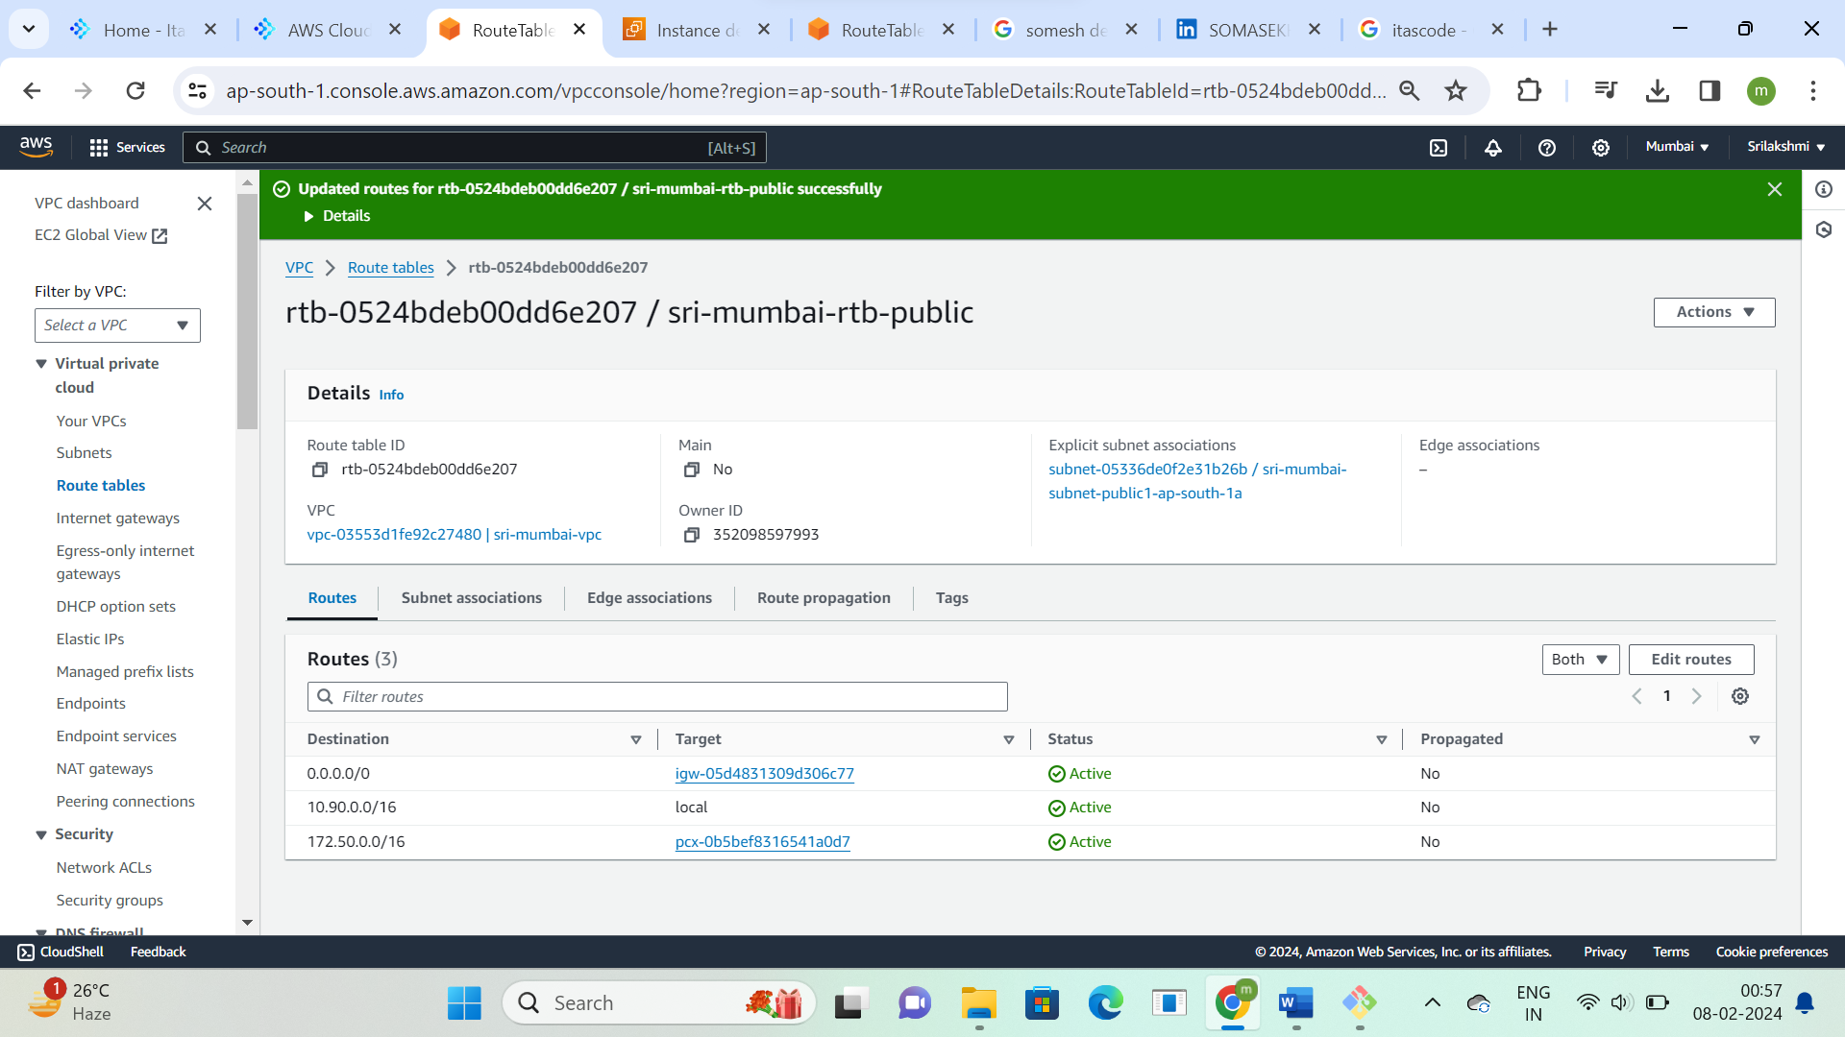

**Copy mumbai region private Ip address**

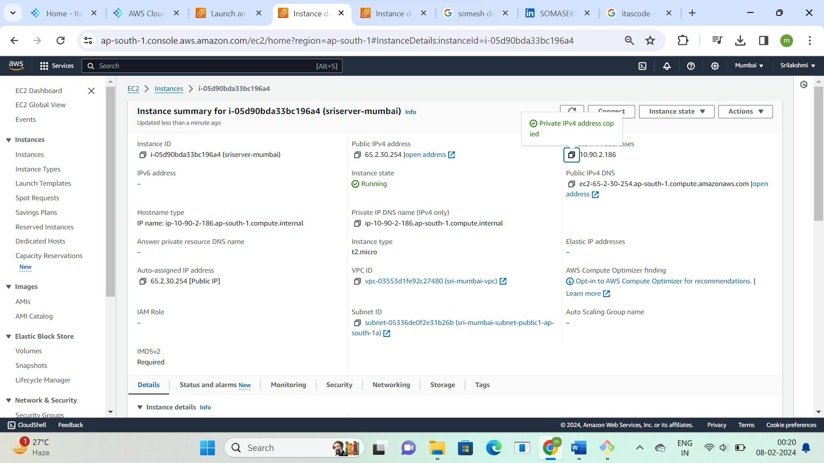

**In hyd region instance ping mumbai region private IP**

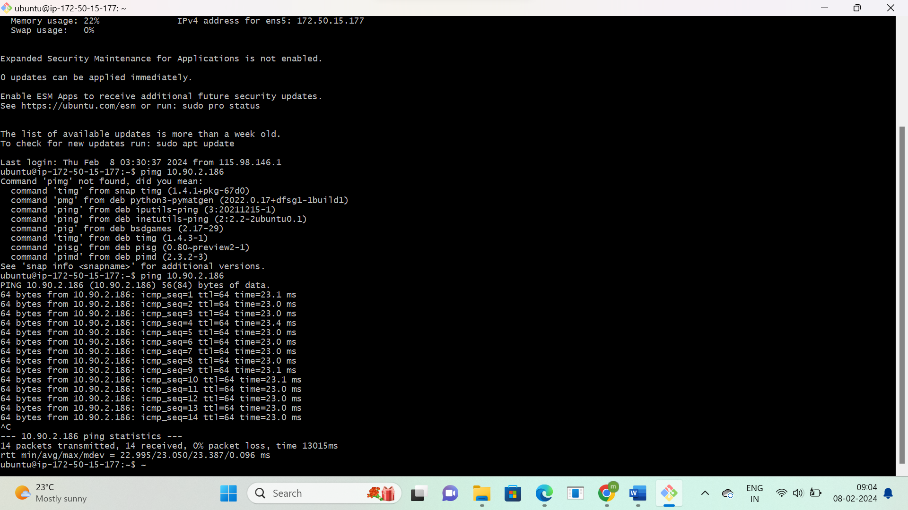

**Copy hyd region private Ip address**

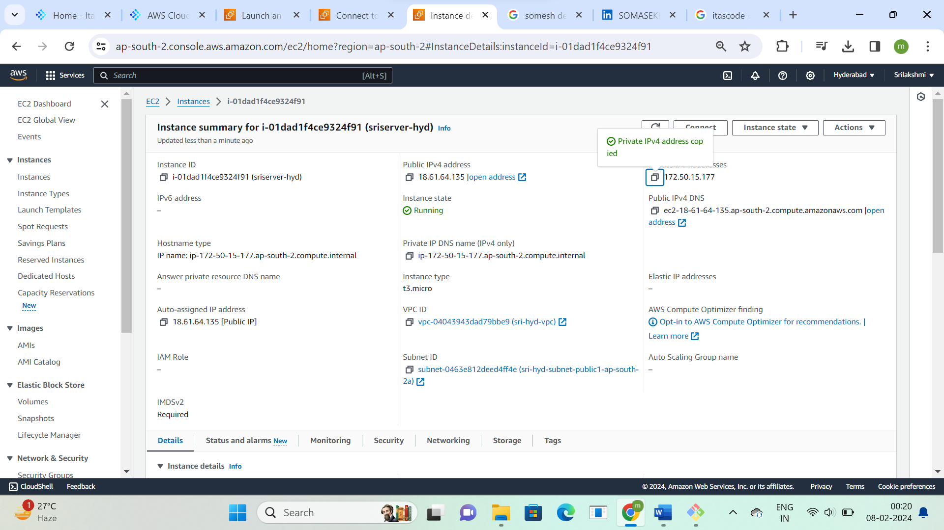

**In mumbai region instance ping hyd region private IP**

